**Institute of Engineering & Technology**

**Devi Ahilya Vishwavidyalaya, Indore (M.P)**

**Department of Computer Science & Engineering**



**DATABASE MANAGEMENT SYSTEM(CER4C4)**

**Lab Assignment-2**

**Submitted To: Submitted By:**

**Mrs. Jyoti Haveliya Mam Tanishq Chauhan (21C4184)**

**CS-Dept CS “B” 2nd Year**

**IET-DAVV Enrollment No:- DE21622**

**Lab Assignment-2**

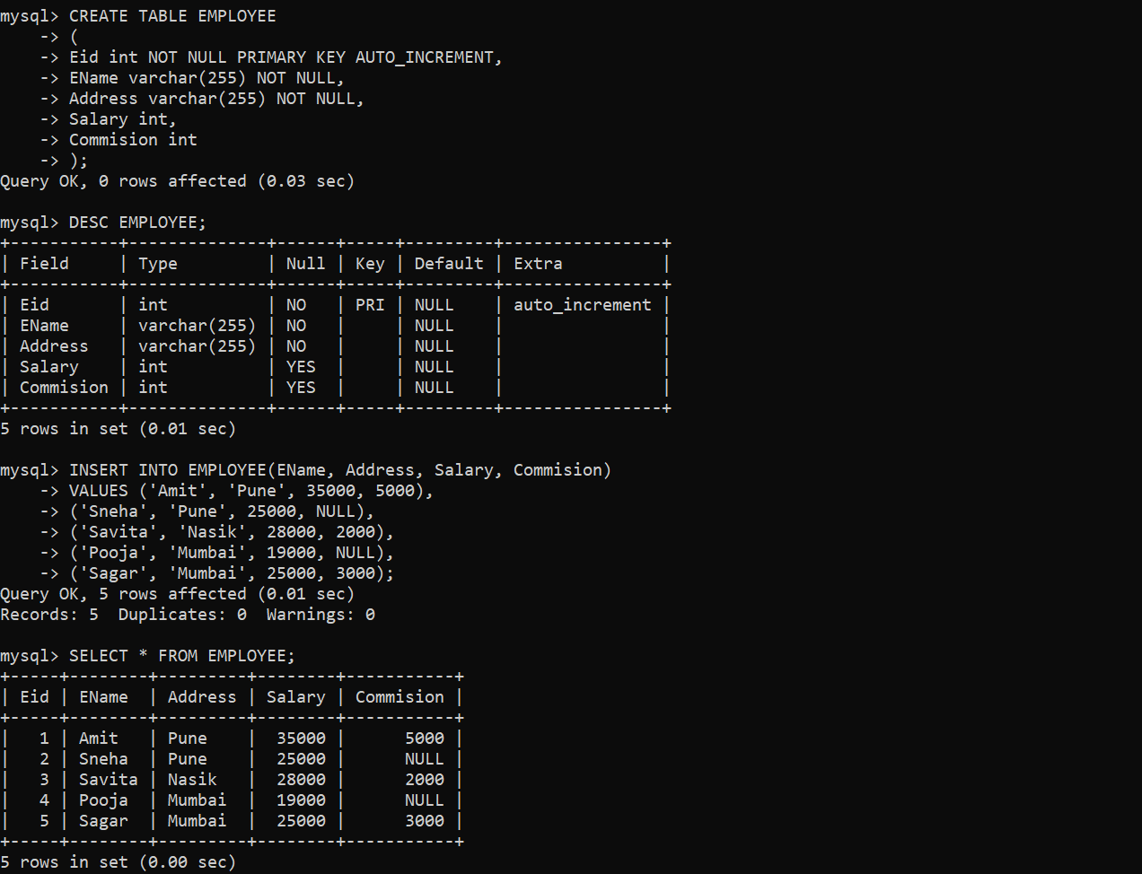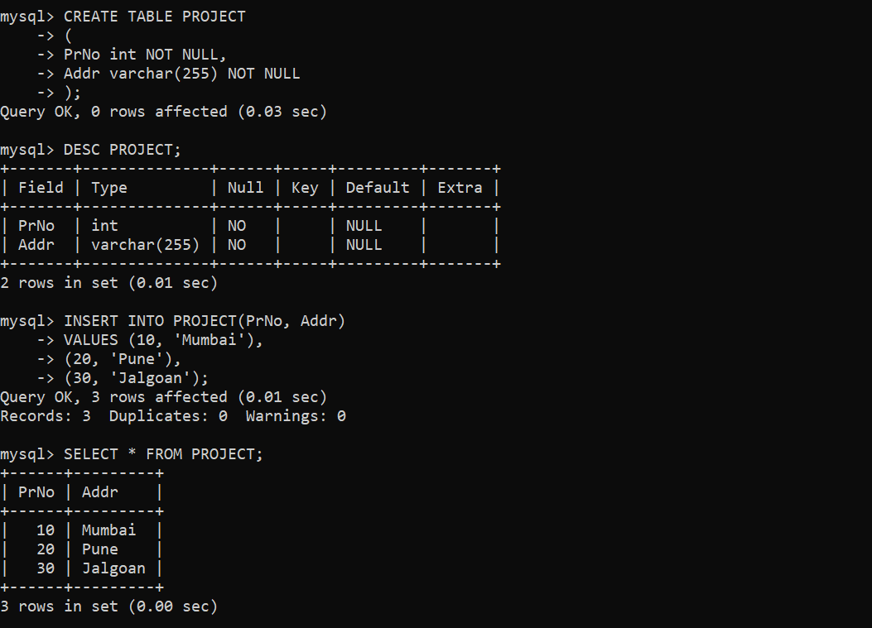**Create EMPLOYEE TABLE, PROJECT TABLE and ADD ROWS shown below:**

**Lab Assignment-2**

1. **Find different locations from where employees belong to?**

**Query:-** SELECT DISTINCT Address AS Locations FROM EMPLOYEE;

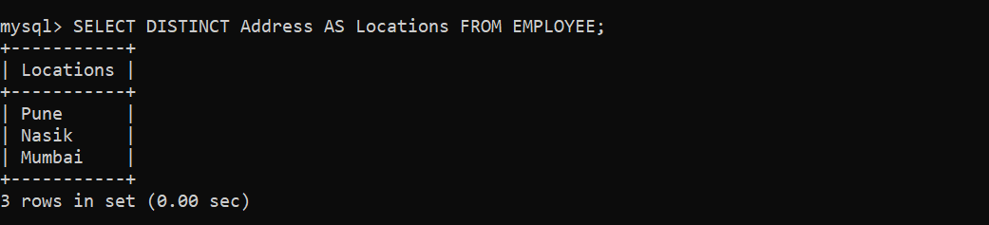

1. **What is maximum and minimum salary?**

**Query:-** SELECT

* MAX(Salary) AS MAXIMUM_SALARY,
* MIN(Salary) AS MINIMUM_SALARY
* FROM EMPLOYEE;

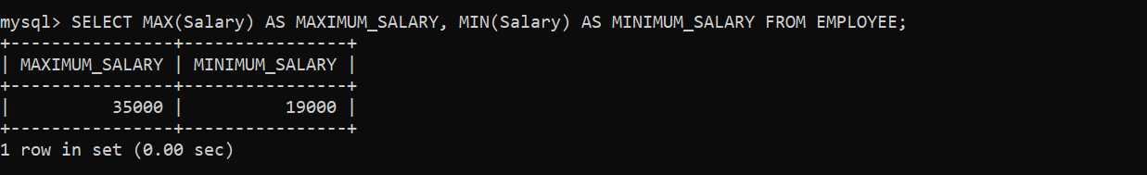

1. **Display the content of employee table according to the ascending order of salary amount.**

**Query:-** SELECT * FROM EMPLOYEE

* ORDER BY Salary;

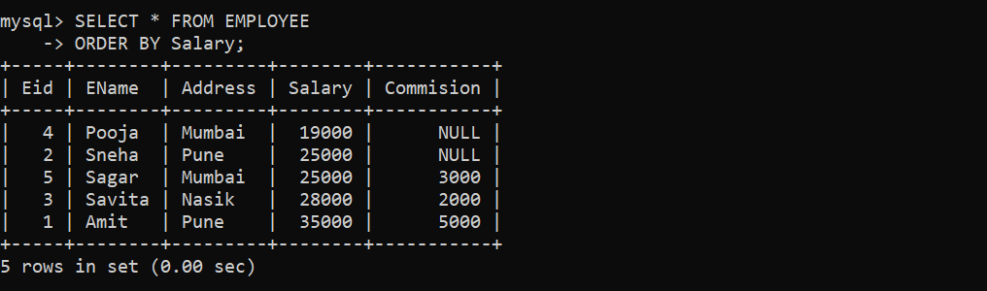

1. **Find the name of employee who lived in Nasik or Pune city.**

**Query:-** SELECT EName, Address

* FROM EMPLOYEE
* WHERE Address = ‘Nasik’
* OR Address = ‘Pune’;

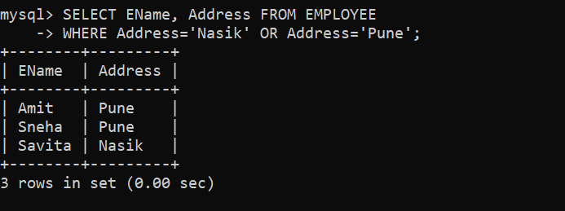

1. **Find the name of employees who does not get commission.**

**Query:-** SELECT EName FROM EMPLOYEE

* WHERE Commision IS NULL;

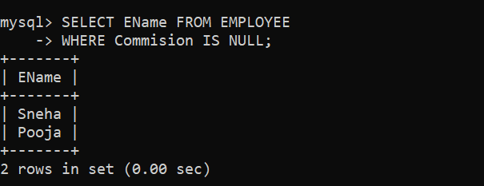

1. **Change the city of Amit to Nashik.**

**Query:-** UPDATE EMPLOYEE

* SET Address = ‘Nasik’
* WHERE EName = ‘Amit’;

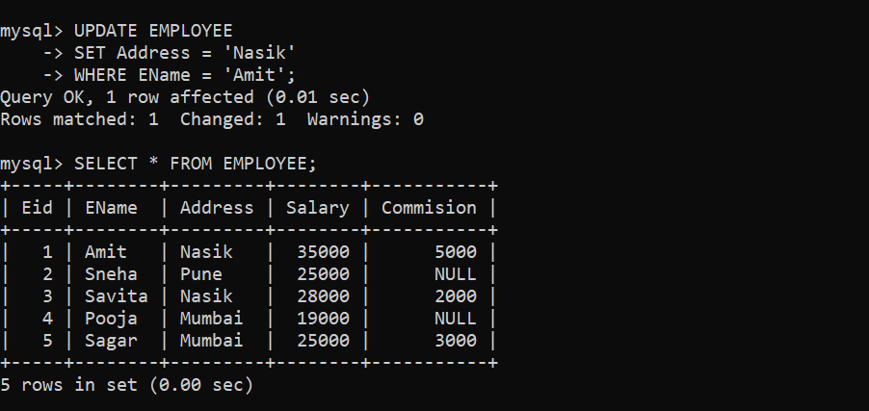

1. **Find the information of employees whose name starts with ‘A’.**

**Query:-** SELECT * FROM EMPLOYEE

* WHERE EName LIKE ‘A%’;

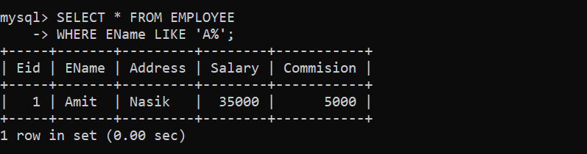

1. **Find the count of staff from Mumbai.**

**Query:-** SELECT COUNT(Address)

* FROM EMPLOYEE
* WHERE Address = ‘Mumbai’;

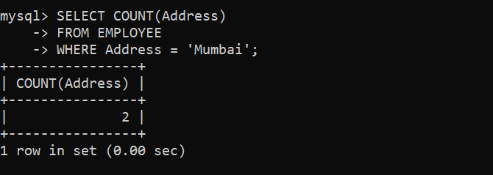

1. **Find the count of staff from each city.**

**Query:-** SELECT Address, COUNT(Address)

* FROM EMPLOYEE
* GROUP BY Address;

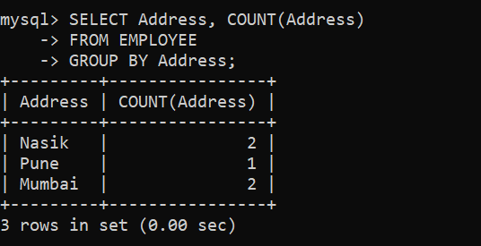

1. **Find the address from where employees are belonging as well as where projects are going on.**

**Query:-** SELECT EMPLOYEE.EName AS NAME,

* EMPLOYEE.Address AS BELONGING_ADDRESS,
* PROJECT.PrNo AS PROJECT_NO,
* PROJECT.Addr AS PROJECT_ADDR
* FROM EMPLOYEE
* JOIN PROJECT ON EMPLOYEE.Address = PROJECT.Addr;

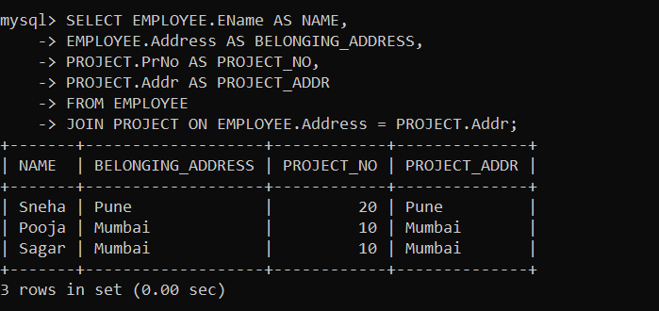

1. **Find city wise minimum salary.**

**Query:-** SELECT Address, MIN(Salary)

* AS MINIMUM_SALARY
* FROM EMPLOYEE
* GROUP BY Address;

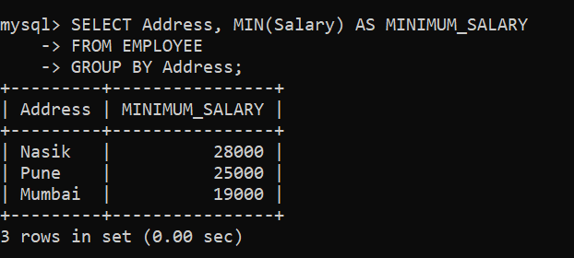

1. **Find city wise maximum salary having maximum salary greater than 26000.**

**Query:-** SELECT Address, MAX(Salary)

* AS MAXIMUM_SALARY
* FROM EMPLOYEE
* GROUP BY Address
* HAVING MAX(Salary) > 26000;

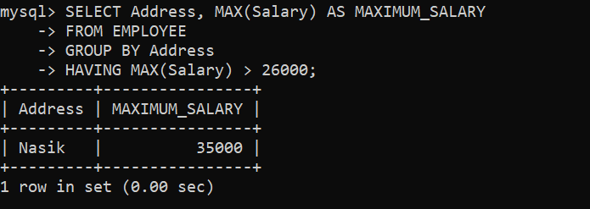

1. **Delete the employee who is having salary greater than 30,000.**

**Query:-** DELETE FROM EMPLOYEE

* WHERE Salary > 30000;

